1. Create and submit a new project
2. 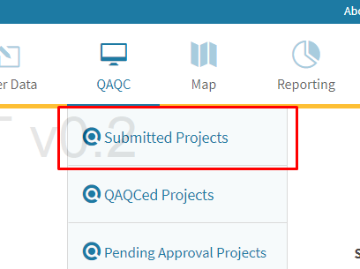A QAQC user can access all submitted projects by hovering over the QAQC menu and clicking Submitted Projects
3. A QAQC user can review and validate the submitted project data and submit it as QAQCed.
4. 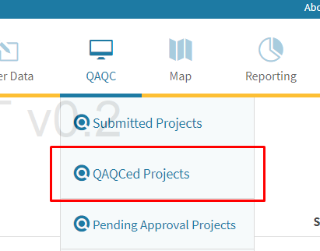All Projects that have been QAQCed are available in the QAQCed Projects option.
5. 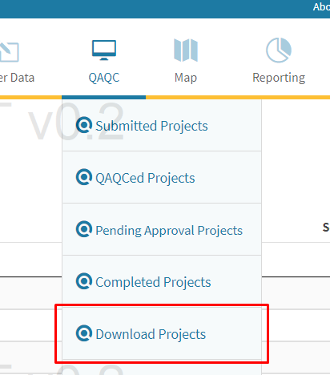All project data that affects baseline data that had been attached in QAQCed projects can now be downloaded as a compressed archive.
6. 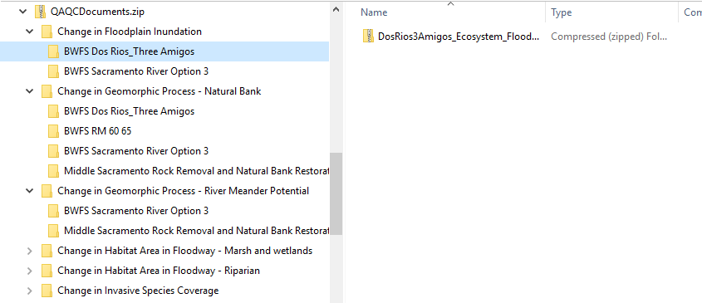Project data is organized by metrics, and further by projects which modified those metrics. In the metric directory the current baseline shapefile will also be included.
7. All metrics affecting the baselines need to be merged into a single baseline and compiled into separate shapefiles, one for each metric.
8. 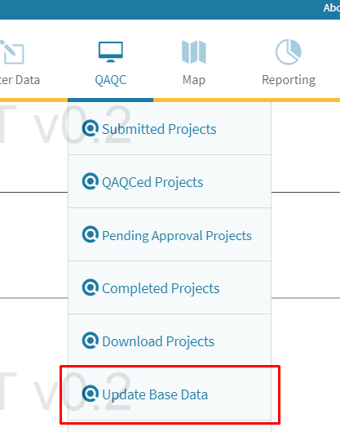The newly updated baselines can be uploaded for staging to replace the current baselines using the Update Baseline view.
9. Update baseline provides several options:
   1. Download the current baseline data for a metric
   2. Stage an updated baseline shapefile for upload.
      1. 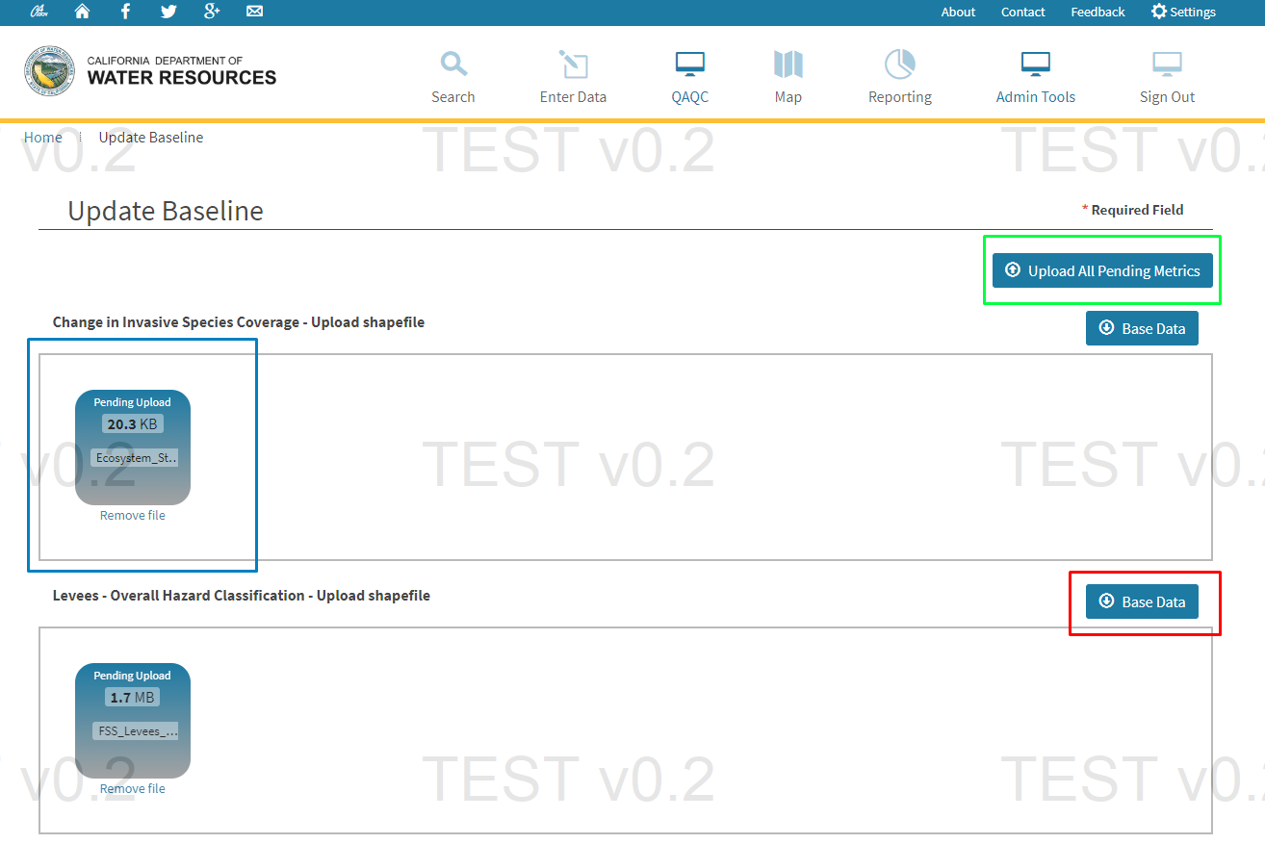After all baseline data that needs to be updated is staged for upload, click Upload All Pending Metrics
10. 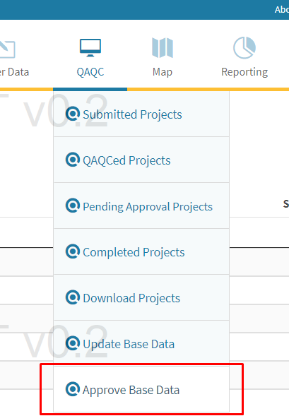After the upload is complete, QAQCed projects transition to a pending approval state, in which the staged baseline data needs to be approved to replace the current baseline data.
11. Staged Metric Base Data view allows a QAQC user to
    1. Download the staged base data
    2. Download current base data
    3. Approve all staged base data to replace the current base data.
       1. 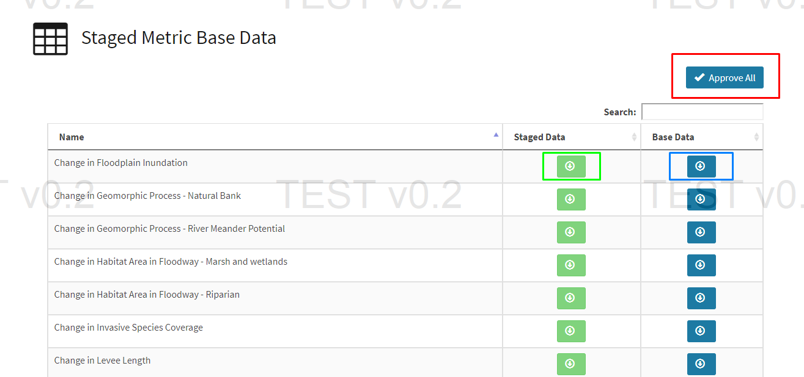This step will transition all projects in pending approval state to completed state